What This File Includes
- A brief summery of what I did in the project
- Description of non explanatory functions
- Units of Time
- The Question pertaining to code efficiency
- Analyzing graphs/worst-case/best-case
Brief Summery
To execute this project I created two classes, one that utilizes the mergesort style of sorting and one that uses bubble sort. The the private members I account for an array of integers that act in storing my values, an integer to store/count the number of swaps and comparisons, and a size integer that tells me how large the array is. Most of the functions are self explanitory as the professor told us to copy off of the slides so instead ill focus on the main cpp file aka driver aka proj2.cpp.
This cpp file runs a menu that gets the user choice on whether they wants to do one run or get the average of 10, it also asks them for the fixed size they desire (as according to the project). Depending on their answer I either run a for loop or just run the process described below once:
- Create an object (merge and bubble)
- Call the Fill function which reads from the file and fills the private array
- Call the respective sort functions and time them
- Store the time and return
- output swaps and comparisons that were counted alongside the execution of the sort functions
- Output the stored time
- Refresh all outputted variables and run again to time how long/how many swaps and comparisons it takes with an already sorted list and output this below our previous output

Description Of Non Explanatory Functions
The main functions that may seem confusing are the generate files function and the AVG function. In this documentation I will explain the purpose of both… The generate files function creates the files and depending on if the user choose the avg case or worst case these files are stored with either random data or data in descending numerical order. The option of how much data also affects how many files are made, if the user desires more data points such as the data points included on the last section for my graph then 6 files are generated, each for a specific data point. This was added for convenience and if the user wishes to only display the 3 data points required of the project then only 3 txt files will be created and stored with data… The avg function does all the main testing and outputting. First the program checks all the possibilities that happened in the menu, if it’s ten runs for example then a for loop run 10 times is called, otherwise the function to calculate time and swaps only run once. In the for loop two objects are filled with data and sent to a function that times their sorting abilties and returns the time as a double, this is done twice, once for time unsorted and once for time sorted. Each time is added to a unique variable so that if the user request the avg of 10 runs then that number can be divided. During the first sort the swaps and comparisons are also stored in temp variables and refreshed before sorting the sorted. Because of this there is a total of 12 variables, 3 for the time, swaps, comparisons of bubble unsorted, 3 for bubble sorted, 3 for merge unsorted, and 3 for merge sorted. If the program runs only once however only these variables are not used because the result function will display the results of one run without having to store in a temp variable… The following process described is used for both a merge and bubble object.
What Are The Time Units
The units of time are in seconds for my program. Please keep this in mind when looking at the graphical analysis as well.
Question And Answer
Q: How is computational efficiency beneficial for economic and social factors? And how is efficient computing/ design of fundamental algorithms aligned with an efficient economy and how can it support the goal for a resource wise and society wise sustainable future?

A: Computational efficiency is beneficial for economic and social factors when you think of extra unnecessary code as pollution. We as society need to cut down on pollution because it is an unnecessary element in our lives that ultimately harms us and slows us down by deteriorating our physical health. Bad programming is similar to a company in that it deteriorates mental health, spending extra time to debug and analyze lines that are not necessary ultimately hurts the company, and this is any company. Having said that think of all the company’s that take effect in our lives, lets say for example that Walmart's algorithm took 1 hour to scan each item’s individual bar code because of bad coding, well that would affect every aspect of not only the company’s life but also our lives. Or lets say that a 911 call took ten extra minutes, think of how essential even 10 minutes is to someone during that time of emergency. Having computational efficiency saves us by giving us the appropriate time everyone needs to function in this society. With computational efficiency companies can get sales done faster, people can be saved in shorter time intervals, the world is a better place as the computing done becomes more and more efficient. Without this efficiency in our lives even simple resources like food could be delayed for weeks due to unnecessary lines that cause errors or poor uses of sorting and manufacturing methods.
Graph Analysis / Best-Avg-Worst Case
For this analysis I was a little confused so I talked to some TA’s Mr.Qin told me to graph the functions and compare how it relates to the theoretical function and Mr.Huan said to Compare absolute worst case (which would be opposite sorted order as in 10 9 8 7 … etc. Included in LogFile). and compare that to the average which is just 10 normal runs of randomly inputted data. I will first attempt Mr.Qin’s suggestion because I think it would be easier to do. And then I will try Mr.Huan’s suggestion although it would be a tad more difficult because entering the numbers for each file in decending order will take some time. If Mr.Huan’s version is empty please consider what that section empty as I might have ran out of time.

Theoretical Expectations :
Bubble is worst is O(n^2) and Avg is still O(n^2)
Merge worst is O(nlogn) and Avg is still O(nlogn)
Tables:
Qin Table (AVG Case, Output in log file):
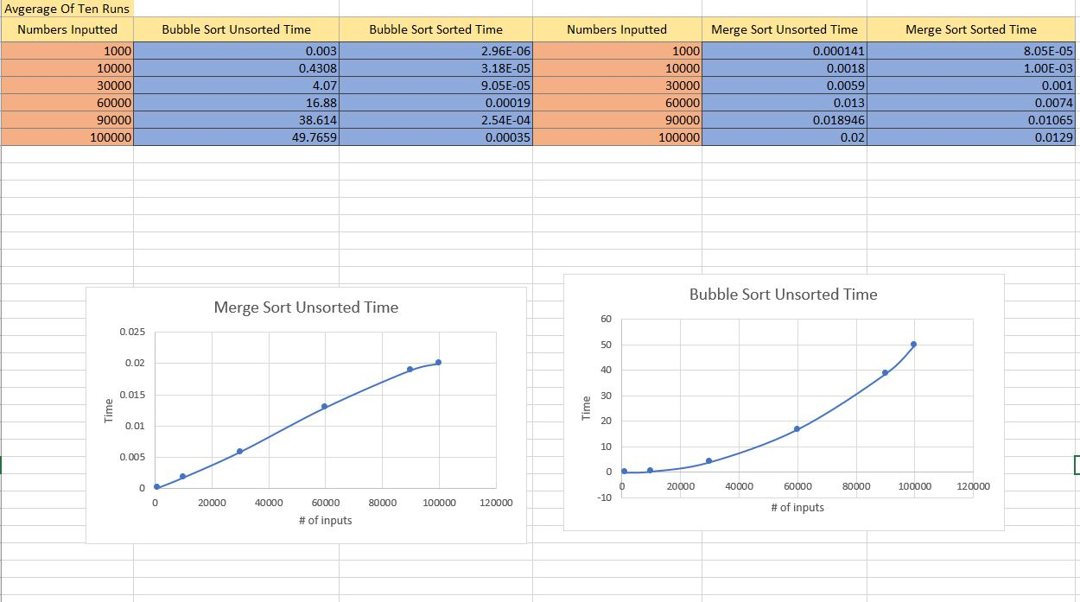
Qin way ~~~ Bubble Sort
Looking at the graph we can see that if more points were added a exponential graph would be formed. Meaning the computational output is going to grow exponentially making sense that the average case would be O(n^2) for the run times nearly double.

Qin way ~~ Merge Sort
Looking at the graph for merge we can see from the y axis that this is clearly a suprior sorting method. There is also a noticable decline unlike the Bubble Sort graph. This shape implied a logn type of graph and can thus be deduced to nlogn which is the average case for merge sort.

Huan Table (Worst Case, Output in log file):
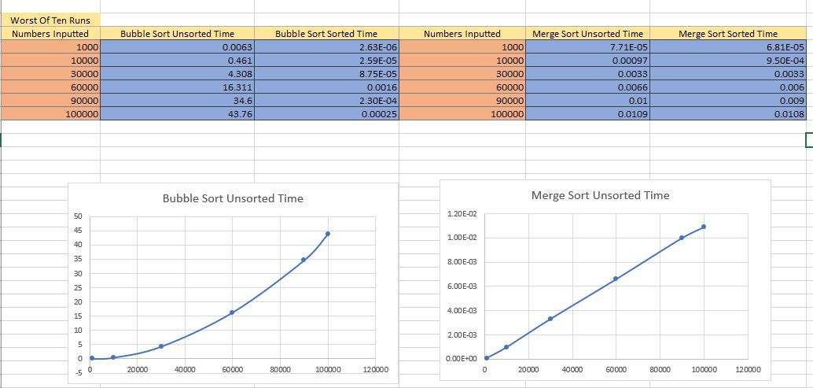
Huan way ~~ Bubble Sort
Looking at the graph we can see the same exact thing as in the Qin case which makes sense because worst case is also O(n^2).
Huan way ~~ Merge Sort
Looking at the graph we can see the same exact thing as in the Qin case which makes sense because worst case is also O(nlogn) except this one is a little more straight which I think it because on google it says the worst case spacing for merge is O(n) so that could also be affecting it.

